Managing emails

Emails are an important part of the corporate record for all organisations. For public sector bodies they are public records and are subject to the Public Records Act, the Data Protection Act and the Freedom of Information Act. Therefore they need to be managed in a way that meets legislative requirements.

All civil servants have an obligation to keep accurate official records under the [Civil Service Code](https://www.gov.uk/government/publications/civil-service-code/the-civil-service-code).

You will need to:

* **define** clearly which emails need to be kept for business or historical value
* **communicate** simply and often to users the rules for what emails to keep
* **keep** emails with related digital information in a shared corporate information management system

**limit** what users can keep in personal email accounts by the use of:  
– email account quotas OR  
– automatic deletion after a set period of time

See our [Guidance principles on the auto-deletion of email](http://www.nationalarchives.gov.uk/documents/information-management/guidance-principles-on-the-deletion-of-email.pdf) (PDF, 0.08 Mb).

Do not use any system that changes an email’s format into one that is no longer usable (e.g. a text file). Find out more about [suitable file formats](http://www.nationalarchives.gov.uk/information-management/manage-information/selection-and-transfer/digital-records-transfer/file-formats-transfer/).

Implementing a policy

It is not necessary to develop an individual policy for the management of emails. They should be covered by the wider information management policy. For some organisations it may, however, be the only way of reinforcing the importance of users’ responsibility to manage all digital information appropriately.

Any policy for email management should reflect your existing information management policy, ensuring it aligns with your [business requirements for information management](http://nationalarchives.gov.uk/documents/information-management/business-requirements-for-managing-digital-information-and-records.pdf) (PDF,  0.19 Mb)

Support users in managing email

Ensure that users understand the benefits to them of managing their email correctly, for instance that emails can be found in a timely way and emails will not be lost as a result of automatic deletion periods.

Lost emails can prevent work from being carried out, create unnecessary duplicated effort or cause damage to the organisation or user through not meeting legislative requirements.

You should ensure that email management is part of the corporate induction process. It is important that leavers file any emails of corporate value and that email accounts are then deleted.

Monitor compliance with corporate information management policies and assess risks. Individual compliance should be reflected, if possible, in staff performance reviews.

Often the issue is a cultural one, where users are simply reluctant or too busy to manage emails. When reviewing why users aren’t managing emails it’s important to check:

* Are they aware of your information management policy?
* Are they aware of their responsibility to manage emails of business value?
* Do they know how to use the systems designed to manage emails?
* Does the system intended to store and manage emails actually work?
* Does the process meet both user and business needs?

The answers to these questions will allow you to form a strategy to enable users to manage emails in the way that you want them to, without impeding their ability to do their job.

Decide which emails to keep

It is tempting to assume that because email metadata provides a ‘receipt’ of correspondence (particularly when used to transmit an attachment) you should keep them all. In practice only a percentage of emails will contain information of [value](http://www.nationalarchives.gov.uk/information-management/manage-information/policy-process/disposal/understand-the-value-of-your-information/) or importance to the business. Keeping all emails will result in a significant storage burden to your organisation, create inefficiency and increase the risk of non-compliance.

By identifying which emails are of value and locating them with other relevant information, you can be more confident that they are [retained only as long as they are required](http://www.nationalarchives.gov.uk/information-management/manage-information/policy-process/disposal/).

Ensure emails remain usable

There is no standard format that emails should be kept in within an information management system. The key aspect in making a decision is that they remain usable. Emails are usable when they can:

* be opened by any user without a specific email application
* show the full content in a readable manner to any user
* show all attachments and allow them to be opened by any user
* be used (forwarded, replied to etc) by any user

Understand the risks around using email archiving systems

While potentially useful for backup purposes in a short to mid-term, the use of email archiving systems presents some risks in terms of information management:

* Loss of contextual information when emails are bundled into a large compressed file
* Difficulty in determining which emails are of value and which can be disposed of due to loss of context
* Inaccurate or inadequate search returns due to large volumes of email
* Over or under restriction on access due to limited access controls
* Inability to implement disposal due to limited disposal functionality

Remember that email archiving systems do not manage email, they only store them.

EMAIL MANAGEMENT SOFTWARE

Guide to Effective Email List & Marketing Management

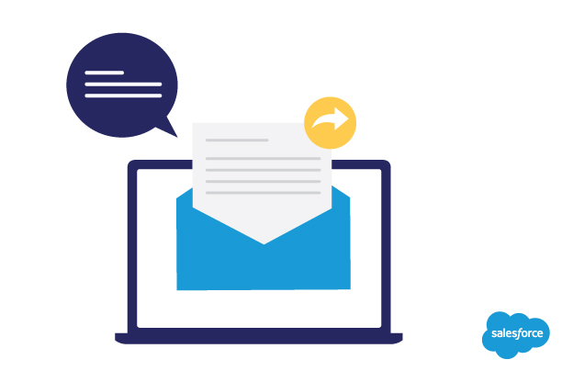

Don’t listen to the naysayers, email isn’t dead. Even with instant messaging, apps, social media, and video chat, email remains an effective means of communication used by billions of people.; However, as effective as email can be, it can also be counter-productive -- particularly in the workplace. When not managed properly, one can spend a good number of hours checking emails and interrupting their productivity.; So how should one best manage their email time? What are the best practices? From email management software to helpful tips to getting to Inbox Zero, managing your email will get employees continue to produce great work without being constantly anchored to their inboxes.

The role of email in modern day business

Email is a critical means of communication in business institutions. Every day emails are sent from employers to employees, customers to suppliers and more—helping all these groups of people to be in touch.

The immediacy with which emails get delivered from one place to another makes it the best means of communication. With emails, employees save time and can have immediate communication and collaboration with employees in and out of the office. With emails, disseminating and transmitting of important information becomes possible, allowing immediate responses to any arising matter.

Emails also serve as a to do list and are a great means of record-keeping without actually record-keeping and having a physical to do list. On receiving emails in your inbox, they remain there for the future response unless you deliberately end up deleting them.

Through the efficient spread of information from one locality to another, emails are important in the marketing of your business products. Email lists allow any interested individual to subscribe through which the company will be sending emails.

The fact that emails are one of the cheapest means of sending information both internally and externally helps businesses cut costs incurred.

Dangers of ineffective email management

Poor use of your email as a means of communication could lead to an unproductive trend among people. When using email to try to resolve a critical issue affecting the company performance, emails are not the best means of communication. Email doesn’t express the emotional intelligence of the sender. It is easy to misread the tone and context of the sender when trying to solve issues in a business organization.

Ineffective email use can also lead to reactive responses. During an argument or debate over a certain issue, people don't pause and think before responding. This provision leads to a reactive response instead of a well-thought solution to a problem.

With ineffective email management, prolonged debates could also arise. This could lead to a waste of time and resources, ending up affecting the production of the company in a negative manner.

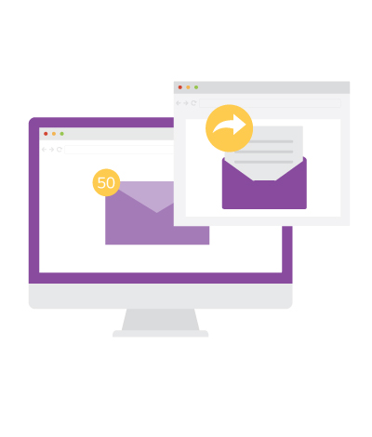

[*27% of service leaders are piloting or planning to use email response management in the next 12-18 months.*](https://secure2.sfdcstatic.com/assets/pdf/misc/state-of-sales-report-salesforce.pdf)

1. Spend less time in your inbox  
   You need to be able to account for every minute you spend in your inbox. Every time you visit your email, time yourself. Check how much time you take to read, process, reply, and sort through emails. This information can help you determine how big of an issue email is to your work productivity. As you see the data, work to limit visits to your inbox each week. Make a rule to only login to your email account when necessary.
2. Learn to prioritize your emails  
   Not all emails you receive are important. Try to apply the 80/20 rule to manage your emails more effectively. The rule states that 20 percent of the inputs are responsible for 80 percent of the outputs in any situation. Learn to focus on the 20 percent of highly important emails that increase the productivity of your business. The 20 percent emails could include: a business interview, networking opportunities, media requests among others.
3. Organize your email  
   Setting up a simple filing system could help you manage your email effectively. Categories such as “Reference”, “Action Items”, and “Waiting” could be used to help manage your filing system. You could also decide to create different folders for every project you are working on in your business organization. Organizing your email in such a way that every supplier and client have different folders could also help keep your mailing system organized.
4. Mark as unread  
   This is a good strategy to apply when trying to save time spent in your inbox. It gives the chance to have a quick glance in your inbox and reply emails that are time pressing and delete those that are not relevant. Mark as unread those items you feel like you should revisit later.
5. Send fewer emails in order to receive fewer emails  
   Try to minimize the number of emails you send in one day. By observing this simple rule, you will have fewer emails to work on in your inbox.
6. Be precise in your responses  
   The words you choose for your responses should be precise and straight to the point. A good choice of words helps avoid ambiguity and possible misinterpretation by the recipient. By being more precise, you will be able to avoid follow-up questions asking for clarity and interpretation of your emails.
7. Use email filters  
   These are tools that automatically sort out your emails when they get into your inbox. You could setup your filters for different emails addresses, subject titles and body texts. The emails get automatically sorted into the respective folders whenever they are delivered. This helps you minimize the administrative duties you need to carry out.
8. Leverage spam filters  
   Email users tend to waste much of their time trying to get rid of spam messages from their email accounts. Spam filter software as well as email management software gets rid of these spam messages, helping you save time.  
     
   A good spam filter includes the ability to block and filter out those spam messages. Good spam filters must be able to protect multiple accounts using a single installation, and they should be compatible with your email client or webmail service provider.

In addition to these tips, organizations should consider using email management software for work emails. Most email software is equipped with spam filters, folders and filters to help keep organization data and email safe.

As an organization, do research to see which email management software best fits your organizational needs. Consider the integration, training, costs and ROI with the email software.

When you take the time to train and implement this new software, you can help the overall work productivity of your organization.

All and all, when organizations integrate effective email management and email management software, employees are more engaged, less distracted and better work gets produced.